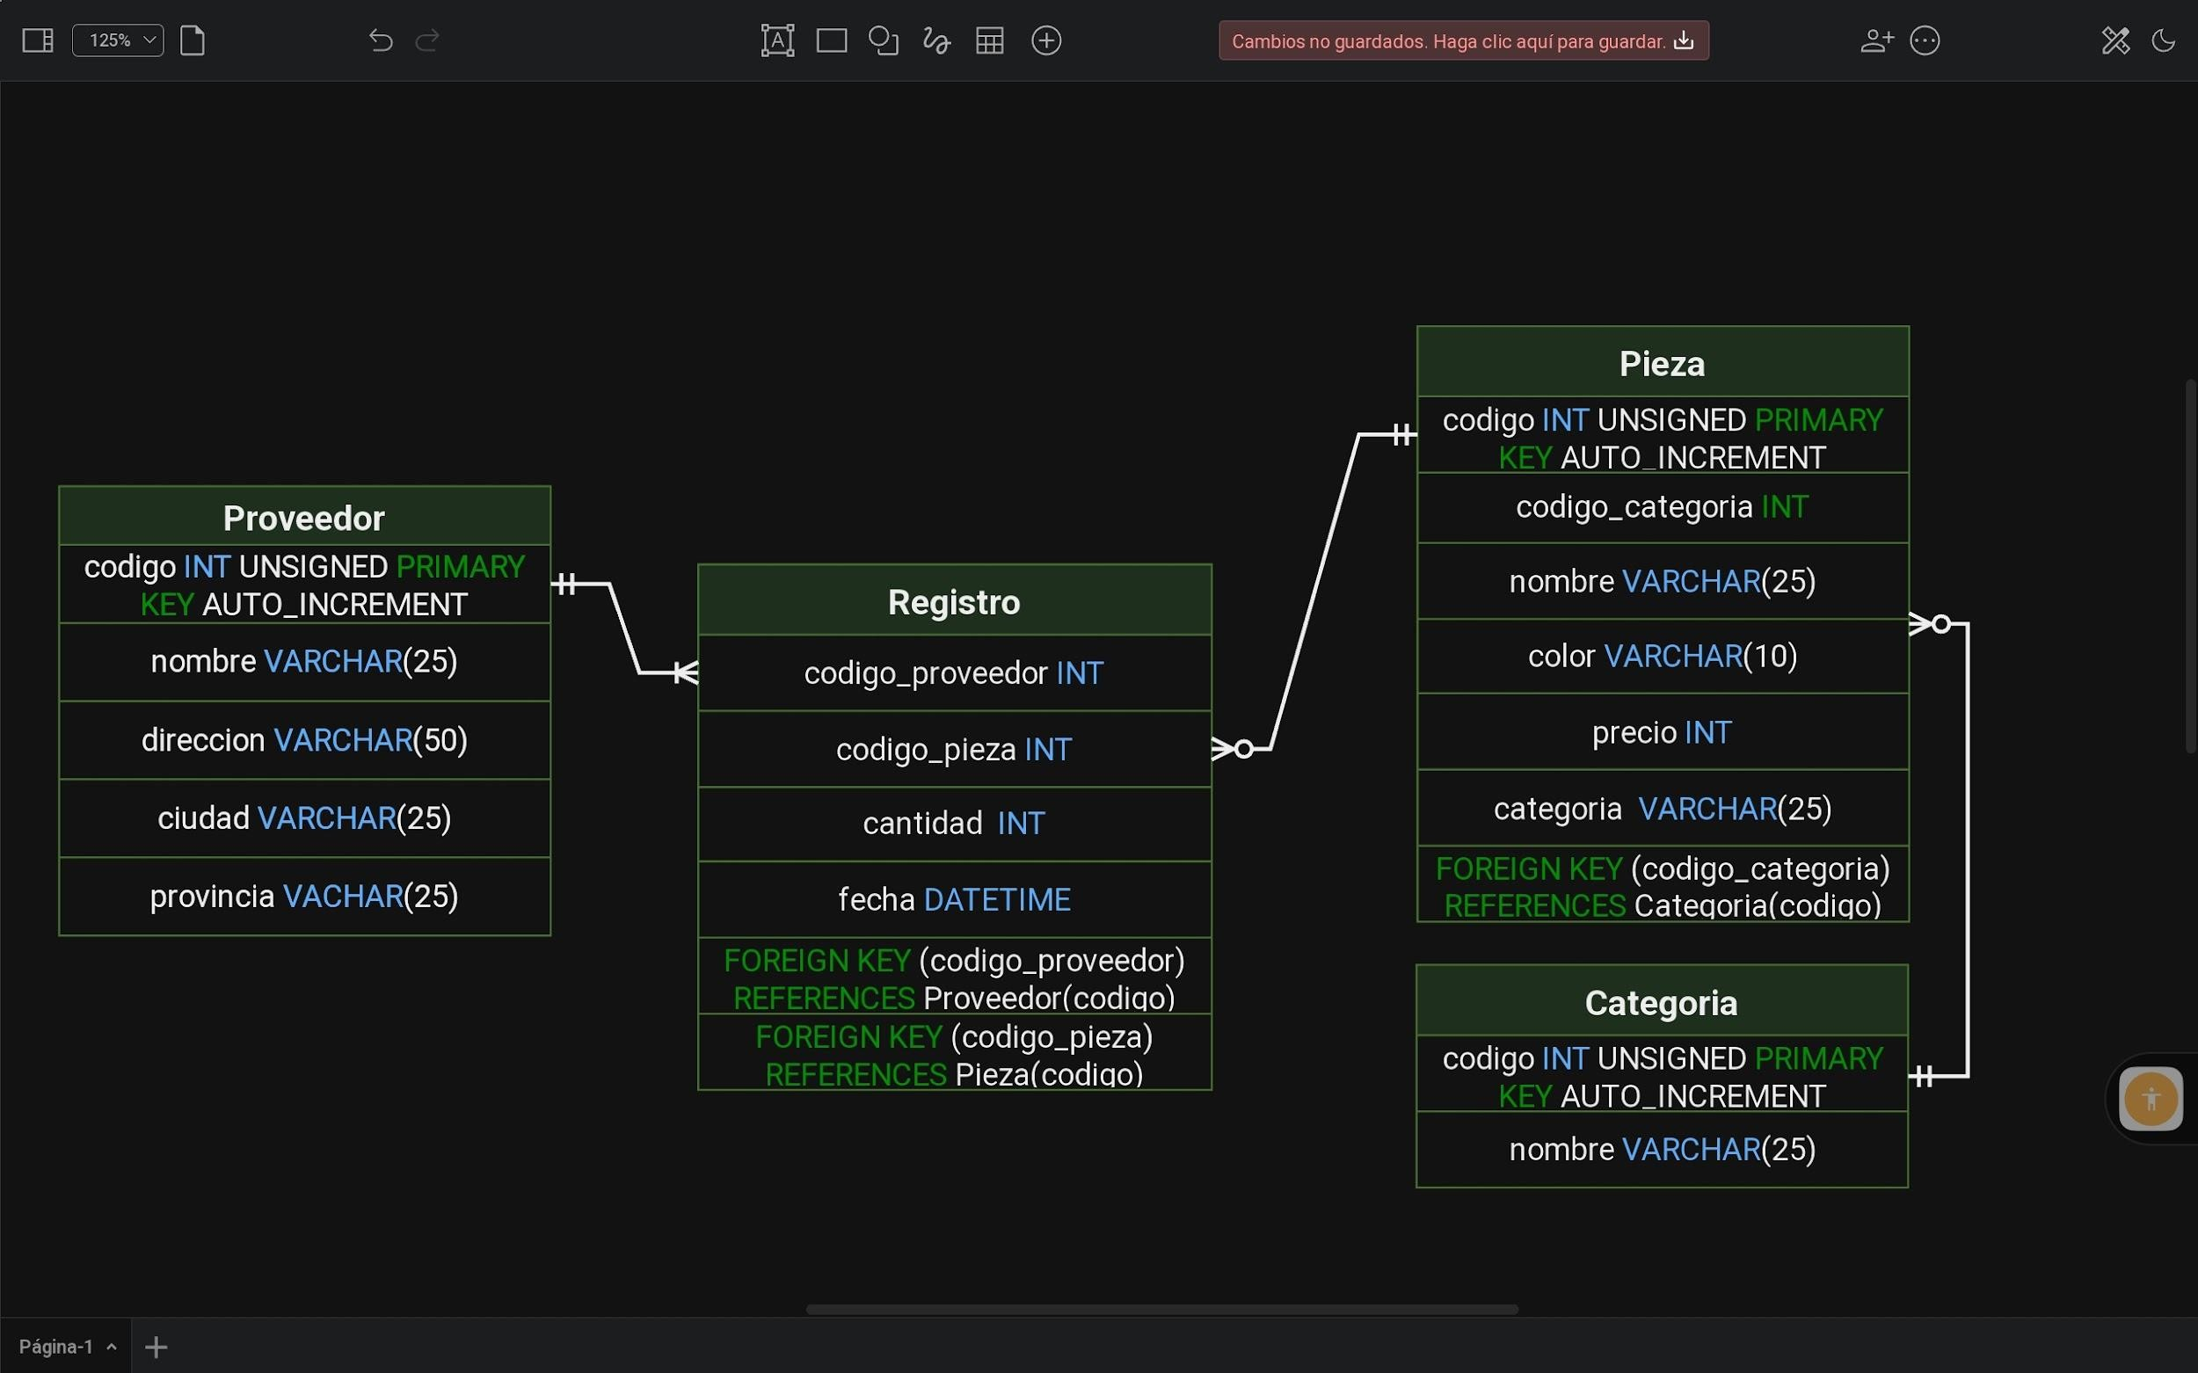

CREATE DATABASE IF NOT EXISTS proveedores CHARACTER SET utf8mb4;

CREATE TABLE IF NOT EXISTS proveedor(

codigo INT UNSIGNED PRIMARY KEY AUTO_INCREMENT, nombre VARCHAR(25) NOT NULL,

direccion VARCHAR(50) NOT NULL, ciudad VARCHAR(25) NOT NULL,

provincia VARCHAR(25)

);

CREATE TABLE IF NOT EXISTS categoria(

codigo INT UNSIGNED PRIMARY KEY AUTO_INCREMENT,

nombre VARCHAR(25)

);

CREATE TABLE IF NOT EXISTS pieza(

codigo INT UNSIGNED PRIMARY KEY AUTO_INCREMENT,

codigo_categoria INT UNSIGNED NOT NULL, nombre VARCHAR(25) NOT NULL,

color VARCHAR(15),

precio INT NOT NULL,

categoria VARCHAR(20) NOT NULL,

FOREIGN KEY (codigo_categoria) REFERENCES categoria(codigo) ON DELETE CASCADE ON UPDATE CASCADE

);

CREATE TABLE IF NOT EXISTS registro(

codigo_proveedor INT UNSIGNED NOT NULL, codigo_pieza INT UNSIGNED NOT NULL, cantidad INT NOT NULL,

fecha DATETIME,

FOREIGN KEY (codigo_proveedor) REFERENCES proveedor(codigo) ON DELETE CASCADE ON UPDATE CASCADE,

FOREIGN KEY (codigo_pieza) REFERENCES pieza(codigo) ON DELETE CASCADE ON UPDATE CASCADE

);